EXPENSE TRACKER SYSTEM
NIDA ANSARI

Machine Learning & Data Science
Internship Program
Month 1 – Practical 3:
Expense Tracker
Submitted By: Nida Ansari

Submitted To: Mr. Farhan Memon (Groot Technology)
Technology Used: Python

Development Environment: Visual Studio Code

- Introduction
An Expense Tracker is a software application used to record and manage daily expenses efficiently. It helps users keep track of their spending habits and monitor financial activities.
This project is a console-based application developed using Python. The system allows users to add expenses, view stored expenses, and generate spending summaries. The project demonstrates the implementation of file handling and data persistence using Python programming concepts.
The application is menu-driven and stores expense records in a text file. It provides a simple and effective way to manage personal expenses through a command-line interface.
- Project Objective
The main objectives of this project are:
• To understand file handling in Python.
• To implement data persistence using files.
• To practice functions and modular programming.
• To store and retrieve expense records from files.
• To generate spending summaries.
• To develop problem-solving skills.
• To create a menu-driven console application.
- Problem Statement
Managing daily expenses manually can be difficult and time-consuming. Users often find it challenging to maintain records of their spending and calculate total expenses.
The Expense Tracker addresses this problem by providing an organized and efficient method for storing expenses and generating spending summaries.
- Features of the System
The application provides the following features:
4.1 Add Expense
Allows users to add a new expense by entering:
• Expense Category
• Expense Amount
4.2 View Expenses
Displays all available expense records stored in the file.
4.3 Spending Summary
Calculates and displays all recorded expenses along with the total amount spent.
4.4 File Storage
Stores expense records permanently in a text file.
4.5 Exception Handling
Handles invalid user inputs and prevents program crashes.
4.6 Exit Program
Terminates the application safely.
- Technologies Used
Technology | Purpose
Python | Application Development
Visual Studio Code | Code Editor
Windows | Operating System
- System Requirements
Hardware Requirements
• Processor: Intel Core i5 or higher
• RAM: 4 GB or above
• Storage: 500 MB free space
Software Requirements
• Python 3.x
• Visual Studio Code
• Windows Operating System
- Data Structures Used
File
A text file is used to store expense records permanently.
Example:
expenses.txt
Food,500
Travel,300
Shopping,1000
Variable
Variables are used to store expense amounts and calculate total spending.
Example:
total_expense = 0
- Functions Used
The following functions are implemented in the project:
add_expense()
Adds a new expense record and stores it in the file.
view_expenses()
Displays all stored expense records.
spending_summary()
Calculates and displays the total expenses.
menu()
Controls the application flow and displays menu options.
Program Flow
Start Program.
Display Main Menu.
User selects an option.
Perform selected operation.
Store or retrieve data from file.
Return to Main Menu.
Exit Program when user selects Exit.
- Algorithm
Step 1
Start the program.
Step 2
Display menu options.
Step 3
Accept user choice.
Step 4
Perform corresponding operation:
• Add Expense
• View Expenses
• Spending Summary
Step 5
Display menu again.
Step 6
Exit when user chooses Exit.
- Sample Output
Main Menu:
- Add Expense
- View Expenses
- Spending Summary
- Exit
Example:
Enter Expense Category: Food
Enter Amount: 500
Expense Added Successfully.
- Screenshots
Insert screenshots here:
Figure 1: Main Menu
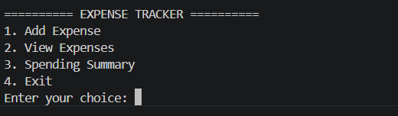

Figure 2: Add Expense
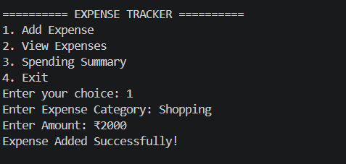
Figure 3: View Expenses
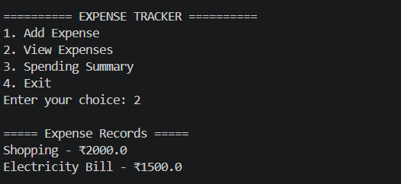
Figure 4: Spending Summary
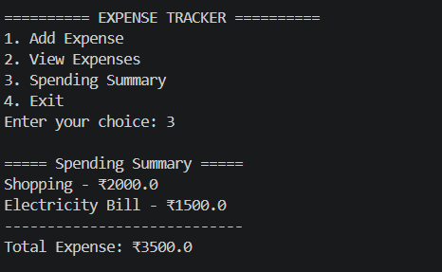

Figure 5: Invalid Input Handling
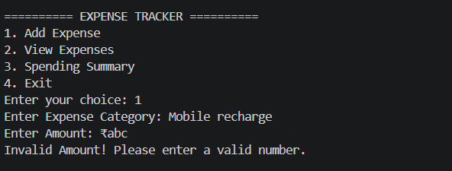
- Learning Outcomes
Through this project, the following concepts were learned:
• Python Fundamentals
• Variables and Data Types
• Functions
• File Handling
• Data Persistence
• Loops
• Conditional Statements
• Exception Handling
• Menu Driven Programming
- Testing :-
Testing Report
Project : Expense Tracker
Test Case ID | Test Scenario | Input | Expected Result | Actual Result | Status
TC-01 | Add Single Expense | Food, 500 | Expense should be saved in file | Expense saved successfully | Pass
TC-02 | Add Multiple Expenses | Food, Travel, Shopping | All expenses should be stored in file | All expenses stored | Pass
TC-03 | Verify Data Persistence | Restart program after adding expenses | Previously saved expenses should remain available | Expenses remained available | Pass
TC-04 | View Stored Expenses | Option 2 | All saved expenses should be displayed | Expenses displayed correctly | Pass
TC-05 | Generate Spending Summary | Option 3 | Total expense should be calculated correctly | Total calculated correctly | Pass
TC-06 | Empty Expense File | Option 2 | Display "No Expenses Found" message | Message displayed | Pass
TC-07 | Summary with No Records | Option 3 | Display "No Expenses Found" message | Message displayed | Pass
TC-08 | Invalid Amount Input | Amount = abc | System should reject invalid input | Error message displayed | Pass
TC-09 | Negative Expense Amount | Amount = -500 | System should reject negative amount | Validation message displayed | Pass
TC-10 | Invalid Menu Choice | 9 | Display invalid choice message | Invalid choice message displayed | Pass
TC-11 | Missing Expense File | Delete expenses.txt and select View Expenses | System should handle missing file gracefully | File not found message displayed | Pass
TC-12 | Exit Application | Option 4 | Program should terminate safely | Program terminated successfully | Pass
Test Summary
Total Test Cases Executed : 12
Passed : 12
Failed:0
Result : The Expense Tracker application successfully stores expense records in files,
maintains data persistence, retrieves saved expenses, and generates accurate spending summaries.

- GitHub Repo. Link :-
Paste your GitHub repository link here.

- Conclusion
The Expense Tracker was successfully developed using Python. The application provides basic expense management functionalities such as adding expenses, viewing stored expenses, and generating spending summaries. Through this project, practical experience was gained in implementing file handling, data persistence, functions, and user interaction. The project serves as a strong foundation for building more advanced financial management systems in the future.

